 

PROGRAM TITLE: BTEC Computing

UNIT TITLE: Programming

ASSIGNMENT NUMBER: 1

ASSIGNMENT NAME: Employee Management Software

SUBMISSION DATE:

DATE RECEIVED:

TUTORIAL LECTURER: Nguyen Phuong Hai

WORD COUNT:

STUDENT NAME: Truong Van Minh

STUDENT ID:BKC15067

MOBILE NUMBER: 0828928569

|  |
| --- |
| **Summative Feedback:** |

|  |
| --- |
| **Internal verification:** |

**Table of content**

I. Define basic algorithms to carry out an operation and outline the process of programming an application. 1

1. Define an algorithm and outline the process in building an application. 1

2. Determine the steps taken from writing code to execution. 2

3. Analyse the process of writing code, including the potential challenges faced. 5

4. Evaluate the implementation of an algorithm in a suitable language and the relationship between the written algorithm and the code variant. 6

II. Explain the characteristics of procedural, object orientated and event-driven programming. 8

1. Discuss what procedural, objectorientated and eventdriven paradigms are; their characteristics and the relationship between them. 8

III. Implement basic algorithms in code using an IDE 11

1. Write a program that implements an algorithm using an IDE. 11

2. Enhance the algorithm written, using the features of the IDE to manage the development process. 15

3. Evaluate the use of an IDE for development of applications contrasted with not using an IDE. 16

IV. Determine the debugging process and explain the importance of a coding standard. 17

1. Explain the coding standard you have used in your code. 17

V. References 18

1. **Define basic algorithms to carry out an operation and outline the process of programming an application.**
2. **Define an algorithm and outline the process in building an application.**

* An algorithm is a well defined instructions that can be used to solve a calculator problems. It maintain a step-by-step procedure that converts an input into a desired output.
* An algorithm is very important roles in computer field and It is also perform for application and information technology field.
* The step of presenting an algorithm:
  + Step 1: Natural language processing (NLP): is a branch of artifical intenlligence (AI) that focuses on developing algorithm to understand and process human language.
  + Step 2: Flow chart: graphical of algorithm
  + Step 3: Pseudo code is defined a step by step description algorithm. It doesn’t use any programming language.

1. **Determine the steps taken from writing code to execution.**

* Write program software the calculator perimeter rectangle:
  + Flowchart:

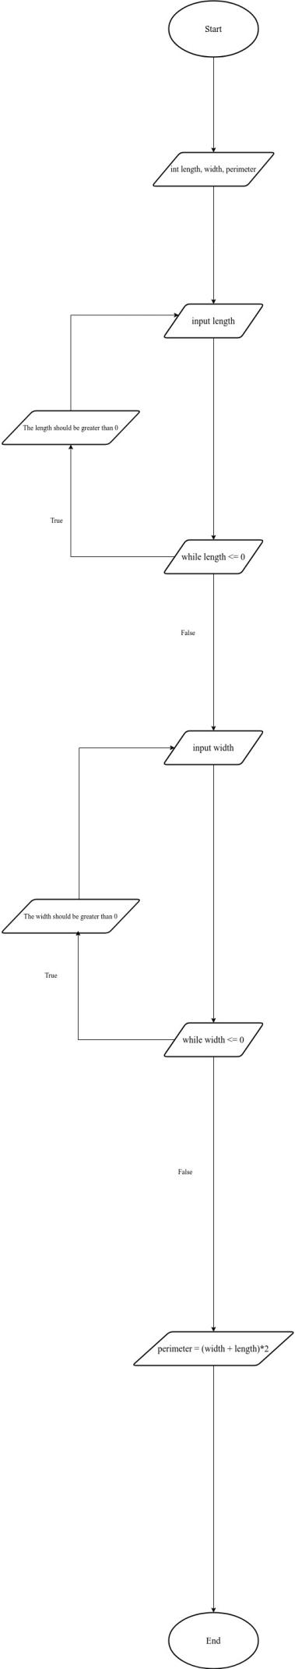

* Source code:

import java.util.Scanner;  
  
public class Main {  
 public static void main(String[] args){  
 Scanner input = new Scanner(System.in);  
 int length, width, perimeter;  
  
 do {  
 System.out.print("Enter length: ");  
 length = input.nextInt();  
 if (length <= 0) {  
 System.out.println("The length of the rectangle should be greater than 0.");  
 }  
 } while (length <= 0);  
 do {  
 System.out.print("Enter width: ");  
 width = input.nextInt();  
 if (width <= 0) {  
 System.out.println("The width of the rectangle should be greater than 0.");  
  
 }  
 } while (width <= 0);  
 perimeter = (length + width) * 2;  
 System.out.println("Perimeter of the rectangle is: " + perimeter);  
 }  
}

* Resualt

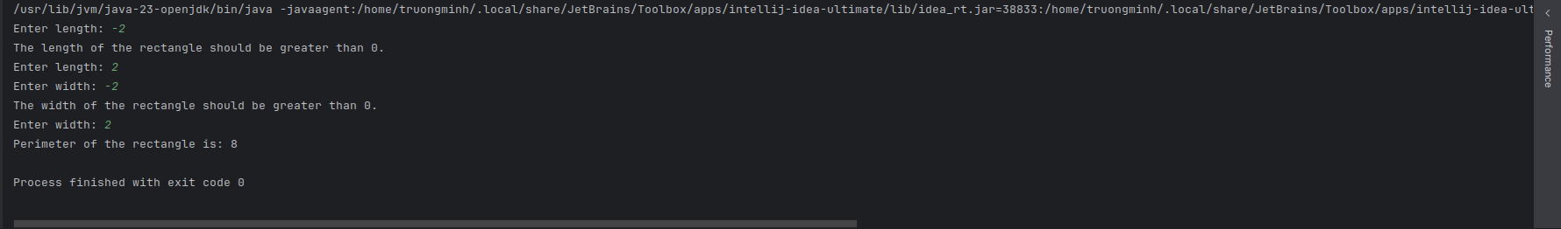

1. **Analyse the process of writing code, including the potential challenges faced**

* The step is problem into Writing code:
  + Debug:
    - * When I finished wrting code and begin testing. It may be errored but I don’t khow where It went wrong line.

1. **Evaluate the implementation of an algorithm in a suitable language and the relationship between the written algorithm and the code variant.**

* An algorithm and Programming language implement of each other:
  + Because: They have more different actitity purposes, such as:
    - An algorithm focus on problem-solving methods and task execution.
    - Programming language focus on presentation indea and source code.
* Use an algorithm and write code on two programming languages: Java, PHP
  + Enter three natural number a, b, c from keyboard. Find the largest number and show resualt on the screen.
    - Java:

import java.util.Scanner;  
  
public class Main {  
 public static void main(String[] args) {  
 Scanner scanner = new Scanner(System.in);  
 int a, b, c, max;  
  
 System.out.print("Enter the first number: ");  
 a = scanner.nextInt();  
 System.out.print("Enter the second number: ");  
 b = scanner.nextInt();  
 System.out.print("Enter the third number: ");  
 c = scanner.nextInt();  
 System.out.println();  
 max = Math.max(a, b);  
 max = Math.max(max, c);  
 System.out.println("The maximum number is: " + max);  
 }  
}

* Resualt:

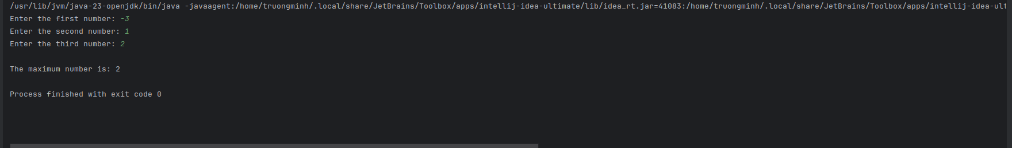

* PHP:

<?php  
do{  
 $a = readline("Enter the first number: ");  
 $a = (int) $a;  
  
 $b = readline("Enter the second number: ");  
 $b = (int) $b;  
  
 $c = readline("Enter the third number: ");  
 $c = (int) $c;  
  
  
  
 $max = $a;  
  
 if ($max < $b){  
 $max = $b;  
 }  
  
 if ($max < $c){  
 $max = $c;  
 }  
 echo "Numbers entered successfully! ";  
  
 echo "Maximum value is: " . $max . PHP_EOL;  
  
 $continue = readline("Do you want to continue?(y/n): ");  
} while (strtolower($continue) !== 'n');  
  
echo "End!" . PHP_EOL;  
?>

* Resualt

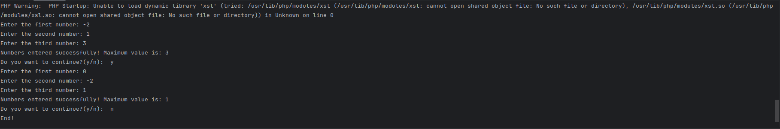

1. **Explain the characteristics of procedural, object orientated and event-driven programming.**
2. **Discuss what procedural, objectorientated and eventdriven paradigms are; their characteristics and the relationship between them.**

* Procedural programming:
  + Define: The procedural language is also known as 3GL, meaning third generation language. It refers to the programming language that denotes a procedure; a set of instructions or guidelines which has to be followed for smooth execution of the program.
  + Characteristics:
    - * Focus on the procedures
      * Use the linear source code
      * Use the local data
* Object orientated programming(OOP):
  + Define: Object orientated programming(OOP) is a languages that use objects in programming. It involves the implementation of real-time entities like inheritance, hiding, polymorphism,.....
  + Characteristics:
    - * Encapsulation: The meaning of encapsulation is that data is wrapped up into a single unit. It binds code and the data it manipulates into a single unit, forming the base feature in object-oriented programming. The variables or data of one class in encapsulation are said to be hidden from any other class, and they can be assessed only through any member function of their class in which these were declared.
      * Abstraction: Data Abstraction is among the most important and vital feature of object-oriented programming. Data Abstraction refers to providing only the essential information about the data to the outside world, which hides the background details or implementation. Let's take a real example of a man who drives his car.
      * Polymorphism: The word polymorphism means having many forms. In simple words, we can define polymorphism as the ability of a message to be displayed in more than one form. For example, a person at the same time can have different characteristics. Like a man at the same time is a father, a husband, an employee. So the same person possesses different behavior in different situations. This is called polymorphism.
      * Inheritance: Inheritance is considered a cornerstone of OOP. It means that the ability of a class to derive properties and characteristics from another class is termed inheritance. When we write any class, we inherit properties from another class. So when we create any class, we do not have to rewrite all the properties and functions again and again, as these can be inherited from any other class that possesses it. Inheritance allows the user to reuse code when it's possible to reduce redundancy.
* Event-driven programming:
  + Define: Event-driven programming is a paradigm in which the program flow is decided by events, for instance, users' actions or messages. The programs perform an action in response to events; this naturally leads to asynchronous, responsive behavior, especially in GUI applications and distributed systems.
  + Characteristics:
    - * Event sources: are the sources that generate events, such as button clicks or sensor data. They simply notify the application about such events without knowing which components are listening for or handling the events.
      * The listeners of events register for certain events and act on them when they occur. When an event is occurring, the listener is notified, and the corresponding event handler calls back the code to handle it.
* Comparation between Procedural Programming and Event-driven programming.
  + Procedural Programming
    - Advantages
      * Easy to understand: Stopping the programmer from writing more lines of code and depicts the code in very simple steps that can be easily
      * Reusability: It allows easy reuse of code
      * Modularity: It breaks the program down into modules or functions use different parts of the memory
      * Simplification: The programmer may understand it
    - Disadvantages:
      * Can’t solve real-life problems
      * It is less secure because they don’t have security data
      * Sematics are hard to get around
  + Event-driven Programming:
    - Advantages:
      * Enables asynchronous processing, enhancing resource utilization and responsiveness, critical for real-time applications and user interfaces.
      * Encourages modular code design, thereby easing maintenance and scaling by separating the concerns, hence reusability of the code.
      * Facilitates easier integration of new features or modifications, promoting adaptability to changing requirements in dynamic environments.
    - Disadvantages:
      * Debugging event-driven systems can be complex because activities are usually done asynchronously, which makes tracing errors difficult.
      * This is because event-driven systems might lead to inversion of control, hence making code less readable by developers not privy to the design.
* In a program, A software often combines more programming paradigms
  + Because:
    - It optimize the program
    - Increase flexibility
    - To take Libraries and tools

1. **Implement basic algorithms in code using an IDE**
2. **Write a program that implements an algorithm using an IDE**

* Image after write code
  + Menu:

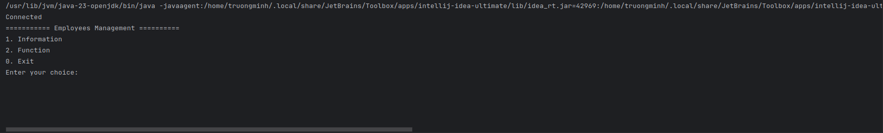

* + Information

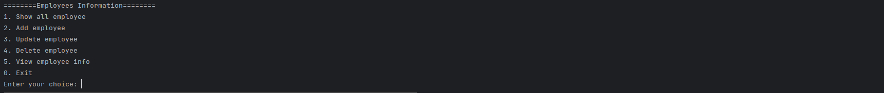

* + Function

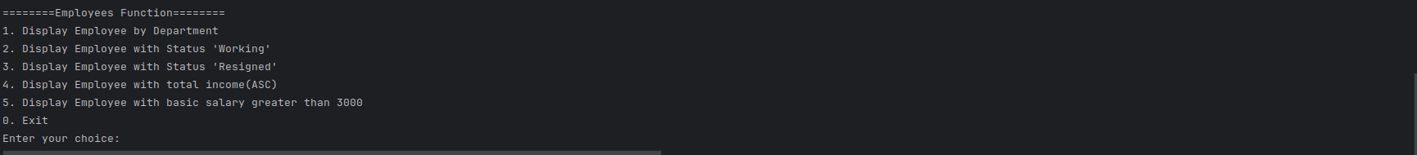

* Flowchart:
  + Add employees

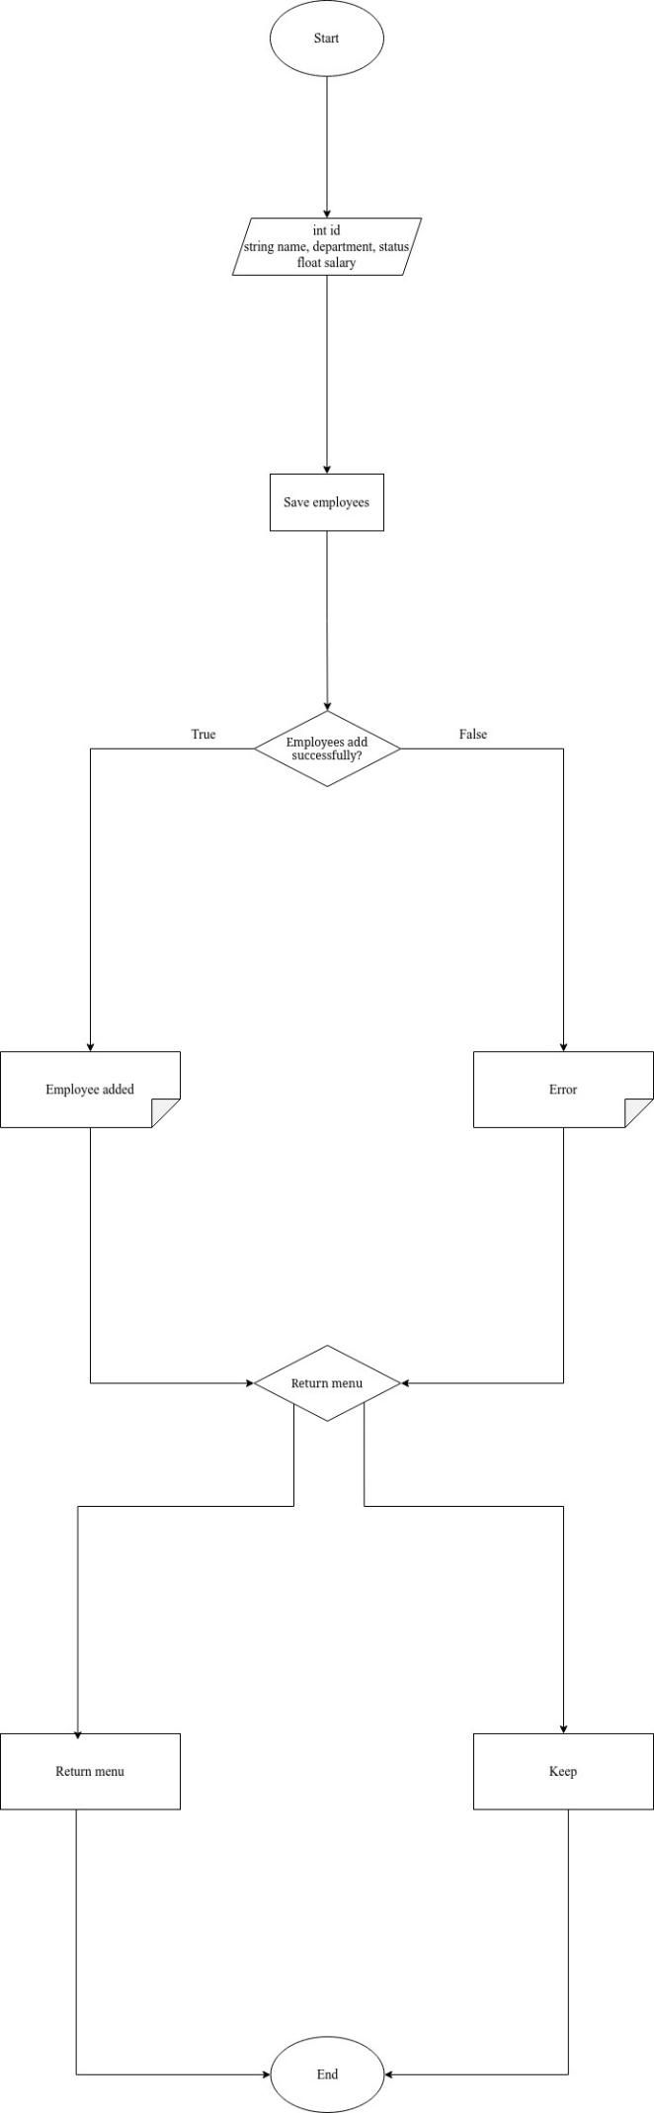

* + Update:

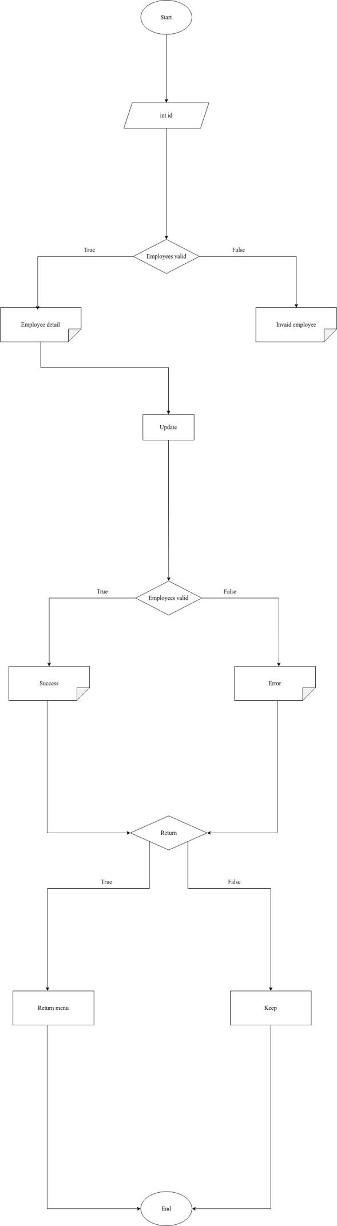

1. **Enhance the algorithm written, using the features of the IDE to manage the development process.**

* The features of the IDE to manage the development process
  + Editor: An editor will normally help a user in writing software code by highlighting syntax with visual cues, providing language-specific auto-completion, and checking for bugs as you type.
    - Example: Jetbrain Intellij IDEA
      * Highlighting syntax: help the programmer easilly identify structure code
      * Auto-completion: The programmer wrtite code fast and reduce error
      * Basic error checking: Search basic error such as spelling mistake
  + Compiter: A compiler is a program that interprets human-readable code into machine-specific code that can run on any operating system, be it Linux, Windows, or Mac OS. Most IDEs usually come with compilers for the language it is supporting.
  + Debugger: Provides a facility for the developers to test and debug their applications, graphically pointing out the locations of bugs or errors, if any.
  + Built-in Terminal: Terminal is a text-based interface used to interact with the machine's OS. Developers can directly run the scripts or commands inside an IDE that has a built-in terminal/console.
  + Version control: Version control helps bring clarity to the development of the software. Some IDEs also support version control tools like Git through which a user can track and manage changes to the software code.
  + Code snippet: IDEs support code snippets, usually used for accomplishing a single task, that can also help reduce redundant work to a great extent.
  + Extension and Plugin: These are used to extend the functionality of the IDEs concerning specific programming languages.
  + Navigation code: IDEs are equipped with code folding, class and method navigation, refactoring tools that enable ease in going through and analyzing codes.

1. **Evaluate the use of an IDE for development of applications contrasted with not using an IDE**

* Advantage when use of an IDE:
  + Project Management:IDEs provide more tools, such as highlighting syntax,.. make it easier to manage project
  + Saving plenty of time and Effort: IDEs are equipped with a range of tools that can not only help you manage your code but also instantly pinpoint the mistake in your code. They also have a flexible combination of tools for compiling, building, testing, and deploying your code through which you'll be able to automate these tasks and thereby wouldn't need to run each task manually.
  + Productivity

1. **Determine the debugging process and explain the importance of a coding standard.**
2. **Explain the coding standard you have used in your code.**

* Coding standard: The good software development organizations want their programmers to maintain some well-defined and standard style of coding called coding standards. They usually create their own coding standards and guidelines, which best suit their organization based on the type of software they are developing. It is very important to maintain the coding standards for the programmers, or else the code will get rejected during code review.

1. **References:**
2. . What is Algorithm | Introduction to Algorithms [Online]. GeeksforGeeks. Available at: <https://www.geeksforgeeks.org/introduction-to-algorithms/.>
3. . What is Procedural Language? [Online]. GeeksforGeeks. Available at: <https://www.geeksforgeeks.org/what-is-procedural-language/.>